Grade: 4 International | Math Worksheet Reteach | Subject: Math
Teacher: Mr. Mohamed 2nd term |  | Date: / / 2026.
Name: ..........................................................................................................

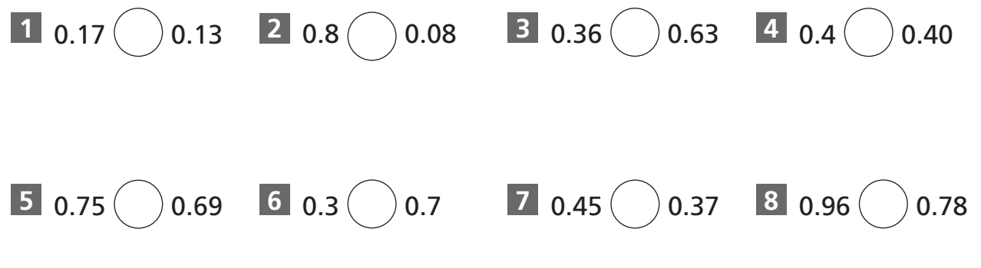
[1] Compare. Write >, < or =

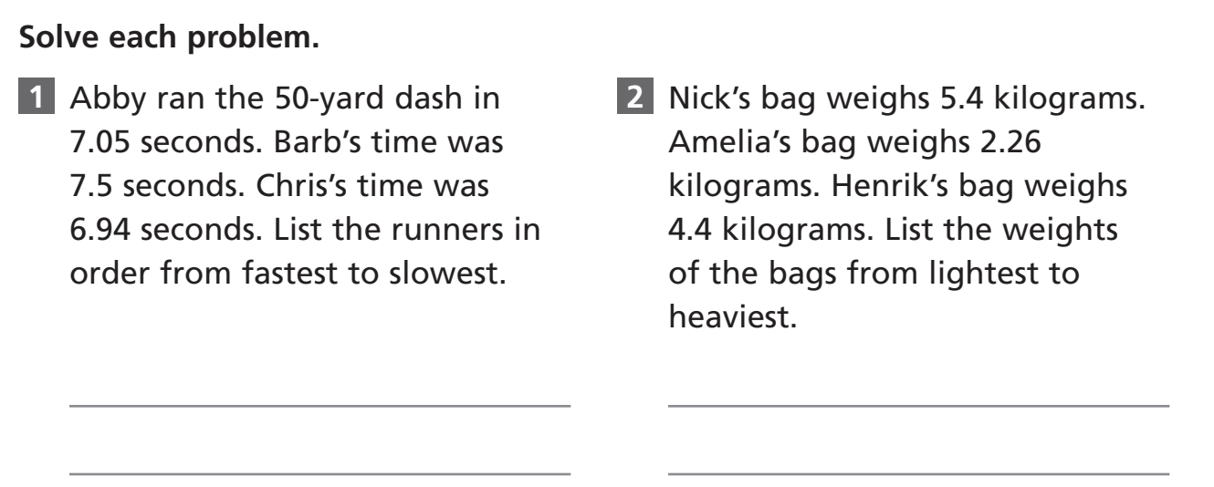
Grade: 4 International | Math Worksheet Enrichment | Subject: Math
Teacher: Mr. Mohamed 2nd term |  | Date: / / 2026.
Name: ..........................................................................................................

